**VISVESVARAYA TECHNOLOGICAL UNIVERSITY**

**“JnanaSangama”, Belgaum -590014, Karnataka.**



**LAB REPORT**

**on**

**Analysis and Design of Algorithms**

***Submitted by***

**ROHIT RAMCHANDRA GANDHI (1BM23CS417)**

***in partial fulfillment for the award of the degree of***

**BACHELOR OF ENGINEERING**

***in***

**COMPUTER SCIENCE AND ENGINEERING**



**B.M.S. COLLEGE OF ENGINEERING**

**(Autonomous Institution under VTU)**

**BENGALURU-560019**

**April-2024 to August-2024**

**B. M. S. College of Engineering,**

**Bull Temple Road, Bangalore 560019**

(Affiliated to Visvesvaraya Technological University, Belgaum)

**Department of Computer Science and Engineering**



**CERTIFICATE**

This is to certify that the Lab work entitled “**Analysis and Design of Algorithms**” carried out by **ROHIT RAMCHNADRA GANDHI(1BM22CS098),** who is bonafide student of **B.M.S. College of Engineering.** It is in partial fulfillment for the award of **Bachelor of Engineering in Computer Science and Engineering** of the Visvesvaraya Technological University, Belgaum during the academic semester April-2024 to August-2024. The Lab report has been approved as it satisfies the academic requirements in respect of an **Analysis and Design of Algorithms (23CS4PCADA)** work prescribed for the said degree.

**Madhavi R.P**  **Dr. Jyothi S Nayak**

Associate Professor Professor and Head

Department of CSE Department of CSE

BMSCE, Bengaluru BMSCE, Bengaluru

**Index Sheet**

|  |  |  |
| --- | --- | --- |
| **Lab Program No.** | **Program Details** | **Page No.** |
| 1 | * Leetcode exercise on Numbers Disappeared in an array. | 1-2 |
| 2 | * Leetcode exercises on binary search tree | 3-4 |
| 3 | * Leetcode exercises on Increasing order search tree | 4 |
| 4 | * Write program to obtain the Topological ordering of vertices in a given digraph using DFS. * Write program to obtain the Topological ordering of vertices in a given digraph using source removal method. | 4-11 |
| 5 | * Sort a given set of N integer elements using selection sort technique and compute its time taken. Run the program for different values of N and record the time taken to sort. * Sort a given set of N integer elements using Merge Sort technique and compute its time taken. Run the program for different values of N and record the time taken to sort. | 12-15 |
| 6 | * Sort a given set of N integer elements using Quick Sort technique and compute its time taken. Run the program for different values of N and record the time taken to sort. | 16-19 |
| 7 | * Implement Johnson Trotter algorithm to generate permutations. * Substring Matching Program. * Leetcode : exercise on Find Kth Largest Integer | 20-22 |
| 8 | * Sort a given set of N integer elements using Heap Sort technique and compute its time taken. * Floyds algorithm. | 23-25 |
| 9 | * Implement 0/1 Knapsack problem using dynamic programming. * Find Minimum Cost Spanning Tree of a given undirected graph using Prim’s algorithm. | 26-29 |
| 10 | * From a given vertex in a weighted connected graph, find shortest paths to other vertices using Dijkstra’s algorithm. * Find Minimum Cost Spanning Tree of a given undirected graph using Kruskal’s algorithm. | 30-34 |

**Course Outcome**

|  |  |
| --- | --- |
| CO1 | Analyze time complexity of Recursive and Non-recursive algorithms using asymptotic notations. |
| CO2 | Apply various design techniques for the given problem. |
| CO3 | Apply the knowledge of complexity classes P, NP, and NP-Complete and prove certain  problems are NP-Complete |
| CO4 | Design efficient algorithms and conduct practical experiments to solve problems. |

**1. Leetcode :exercise on Numbers Disappeared in an array.**

**448. Find All Numbers Disappeared in an Array:**

**Given an array nums of n integers where nums[i] is in the range [1, n], return an array of all the integers in the range [1, n] that do not appear in nums.**

int* findDisappearedNumbers(int* nums, int numsSize, int* returnSize) {

int temp = 0;

for (int index = 0; index < numsSize; ++index) {

temp = abs(nums[index]) - 1;

nums[temp] = abs(nums[temp]) * -1; }

int insert_index = 0;

*returnSize = 0;

for (int index = 0; index < numsSize; ++index) {

if (nums[index] > 0) {

++*returnSize;

nums[insert_index++] = index + 1; }



1. **Leetcode :exercises on Binary Tree Zigzag Level Order Traversal**

**103. Binary Tree Zigzag Level Order Traversal**

**Given the root of a binary tree, return the zigzag level order traversal of its nodes' values. (i.e., from left to right, then right to left for the next level and alternate between).**

int** zigzagLevelOrder(struct TreeNode* root, int* returnSize, int** returnColumnSizes) {

int **ans = malloc(2000*sizeof(int*));

*returnColumnSizes = malloc(2000*sizeof(int));

*returnSize = 0;

struct TreeNode *tmp[2000] ={0};

int top = -1, start = 0;

tmp[++top] = root;

while(tmp[start])

{

int tmp_top = top;

ans[(*returnSize)] = malloc((top-start+1)*sizeof(int));

(*returnColumnSizes)[(*returnSize)] = (top-start+1);

int idx = (*returnSize)%2 ? (top-start+1)-1:0;

int step = (*returnSize)%2 ? -1:1;

while(start <= tmp_top)

{

ans[(*returnSize)][idx] = tmp[start]->val;

if(tmp[start]->left)

tmp[++top] =tmp[start]->left;

if(tmp[start]->right)

tmp[++top] =tmp[start]->right;

start++;

idx += step;

}

(*returnSize)++;

}

return ans;



1. **Leetcode :exercises on Increasing Order Search Tree**

**Given the root of a binary search tree, rearrange the tree in in-order so that the leftmost node in the tree is now the root of the tree, and every node has no left child and only one right child.**

// struct TreeNode* rotRight(struct TreeNode* root) {

// struct TreeNode* temp = root->left;

// struct TreeNode* ptr = root->left;

// while (ptr->right) {

// ptr = ptr->right;

// }

// ptr->right = root;

// root->left = NULL;

// return temp;

// }

struct TreeNode* increasingBST(struct TreeNode* root) {

if (!root)

return root;

struct TreeNode* lft = increasingBST(root->left);

if (lft){

struct TreeNode* temp = lft;

while (temp->right)

temp = temp->right;

root->left = NULL;

temp->right = root;

root->right = increasingBST(root->right);

root = lft;

}

else

root->right = increasingBST(root->right);

return root;

}



1. **(a) Write a program to obtain the Topological ordering of vertices in a given digraph using DFS.**

**#include <stdio.h>**

**#include <stdlib.h>**

**#define MAX_VERTICES 100**

**typedef struct {**

**int vertices[MAX_VERTICES];**

**int top;**

**} Stack;**

**void push(Stack *s, int value) {**

**s->vertices[++s->top] = value;**

**}**

**int pop(Stack *s) {**

**return s->vertices[s->top--];**

**}**

**int isEmpty(Stack *s) {**

**return s->top == -1;**

**}**

**void topologicalSortUtil(int v, int visited[], Stack *stack, int graph[][MAX_VERTICES], int n) {**

**visited[v] = 1;**

**for (int i = 0; i < n; i++) {**

**if (graph[v][i] && !visited[i]) {**

**topologicalSortUtil(i, visited, stack, graph, n);**

**}**

**}**

**push(stack, v);**

**}**

**void topologicalSort(int n, int graph[][MAX_VERTICES]) {**

**Stack stack;**

**stack.top = -1;**

**int visited[MAX_VERTICES] = {0};**

**for (int i = 0; i < n; i++) {**

**if (!visited[i]) {**

**topologicalSortUtil(i, visited, &stack, graph, n);**

**}**

**}**

**while (!isEmpty(&stack)) {**

**printf("%d ", pop(&stack));**

**}**

**printf("\n");**

**}**

**int main() {**

**int n;**

**printf("Enter the number of vertices in the graph: ");**

**scanf("%d", &n);**

**int graph[MAX_VERTICES][MAX_VERTICES] = {0};**

**printf("Enter the adjacency matrix of the graph:\n");**

**for (int i = 0; i < n; i++) {**

**for (int j = 0; j < n; j++) {**

**scanf("%d", &graph[i][j]);**

**}**

**}**

**printf("\nTopological sorting of vertices:\n");**

**topologicalSort(n, graph);**

**return 0;**

**}**

**OUTPUT:**

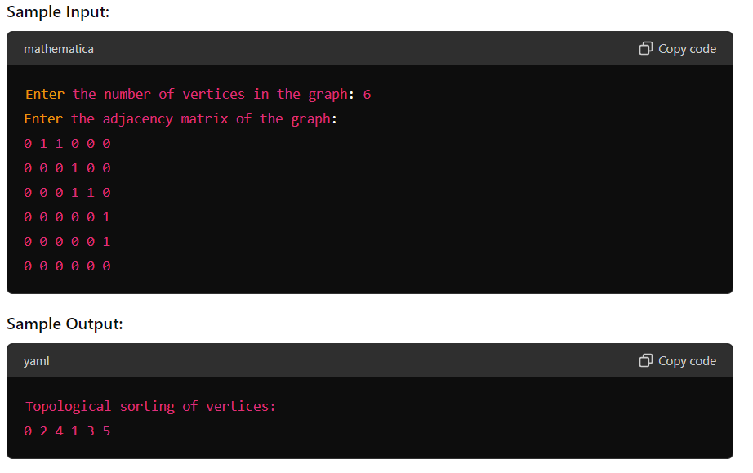

**(b) Write a program to obtain the Topological ordering of vertices in a given digraph using Source Removal method.**

#include <stdio.h>

#include <stdlib.h>

#define MAX_VERTICES 100

typedef struct Queue

{

int items[MAX_VERTICES];

int front;

int rear;

} Queue;

void enqueue(Queue *q, int value);

int dequeue(Queue *q);

int isEmpty(Queue *q);

void topologicalSort(int n, int graph[][MAX_VERTICES]);

int main()

{

int n;

printf("Enter the number of vertices in the graph: ");

scanf("%d", &n);

int graph[MAX_VERTICES][MAX_VERTICES] = {0};

printf("Enter the adjacency matrix of the graph:\n");

for (int i = 0; i < n; i++)

{

for (int j = 0; j < n; j++)

{

scanf("%d", &graph[i][j]);

}

}

printf("\nTopological sorting of vertices:\n");

topologicalSort(n, graph);

return 0;

}

void topologicalSort(int n, int graph[][MAX_VERTICES])

{

int indegree[MAX_VERTICES] = {0};

Queue q;

q.front = -1;

q.rear = -1;

for (int i = 0; i < n; i++)

{

for (int j = 0; j < n; j++)

{

if (graph[i][j] == 1)

{

indegree[j]++;

}

}

}

for (int i = 0; i < n; i++)

{

if (indegree[i] == 0)

{

enqueue(&q, i);

}

}

while (!isEmpty(&q))

{

int vertex = dequeue(&q);

printf("%d ", vertex);

for (int i = 0; i < n; i++)

{

if (graph[vertex][i] == 1)

{

if (--indegree[i] == 0)

{

enqueue(&q, i);

}

}

}

}

printf("\n");

}

void enqueue(Queue *q, int value)

{

if (q->rear == MAX_VERTICES - 1)

{

printf("Queue is full\n");

}

else

{

if (q->front == -1)

{

q->front = 0;

}

q->rear++;

q->items[q->rear] = value;

}

}

int dequeue(Queue *q)

{

int item;

if (isEmpty(q))

{

printf("Queue is empty\n");

item = -1;

}

else

{

item = q->items[q->front];

q->front++;

if (q->front > q->rear)

{

q->front = q->rear = -1;

}

}

return item;

}

int isEmpty(Queue *q)

{

if (q->rear == -1)

{

return 1;

}

else

{

return 0;

}

}

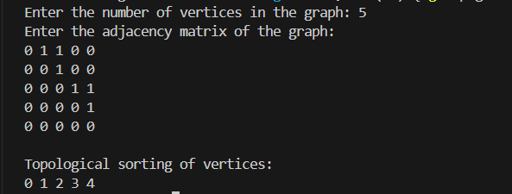

1. **Sort a given set of N integer elements using selection sort technique and compute its time taken. Run the program for different values of N and record the time taken to sort.**

include <stdio.h>

#include <time.h>

#include <stdlib.h>

void selsort(int n, int a[]);

int main() {

int a[15000], n, i, j, ch, temp;

clock_t start, end;

while (1) {

printf("\n1: For manual entry of N value and array elements");

printf("\n2: To display time taken for sorting number of elements N in the range 500 to 14500");

printf("\n3: To exit");

printf("\nEnter your choice: ");

scanf("%d", &ch);

switch (ch) {

case 1:

printf("\nEnter the number of elements: ");

scanf("%d", &n);

printf("\nEnter array elements: ");

for (i = 0; i < n; i++) {

scanf("%d", &a[i]);

}

start = clock();

selsort(n, a);

end = clock();

printf("\nSorted array is: ");

for (i = 0; i < n; i++)

printf("%d\t", a[i]);

printf("\nTime taken to sort %d numbers is %f Secs", n, (((double)(end - start)) / CLOCKS_PER_SEC));

break;

case 2:

n = 500;

while (n <= 14500) {

for (i = 0; i < n; i++) {

//a[i] = rand() % 1000;

a[i] = n - i;

}

start = clock();

selsort(n, a);

//Dummy loop to create delay

for (j = 0; j < 500000; j++) {

temp = 38 / 600;

}

end = clock();

printf("\nTime taken to sort %d numbers is %f Secs", n, (((double)(end - start)) / CLOCKS_PER_SEC));

n = n + 1000;

}

break;

case 3:

exit(0);

}

getchar();

}

return 0;

}

void selsort(int n, int a[]) {

int i, j, t, small, pos;

for (i = 0; i < n - 1; i++) {

pos = i;

small = a[i];

for (j = i + 1; j < n; j++) {

if (a[j] < small) {

small = a[j];

pos = j;

}

}

t = a[i];

a[i] = a[pos];

a[pos] = t;

}

}

OUTPUT:

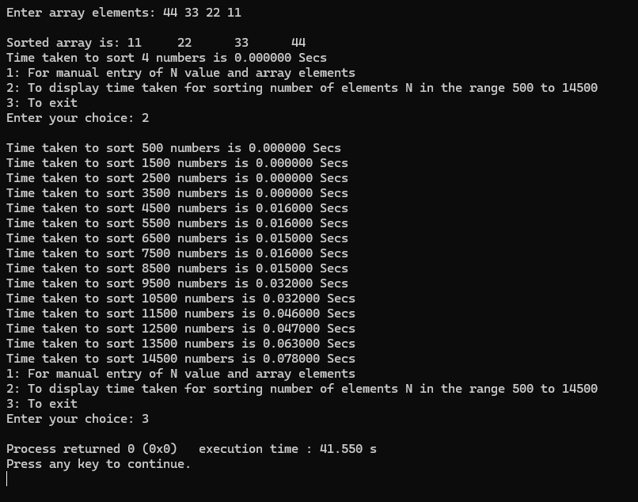

**(B)Sort a given set of N integer elements using Merge Sort sort technique and compute its time taken. Run the program for different values of N and record the time taken to sort.**

#include<stdio.h>

#include<time.h>

#include<stdlib.h> /* To recognise exit function when compiling with gcc*/

void split(int[],int,int);

void combine(int[],int,int,int);

void main()

{

int a[15000],n, i,j,ch, temp;

clock_t start,end;

while(1)

{

printf("\n1:For manual entry of N value and array elements");

printf("\n2:To display time taken for sorting number of elements N in the range 500 to 14500");

printf("\n3:To exit");

printf("\nEnter your choice:");

scanf("%d", &ch);

switch(ch)

{

case 1: printf("\nEnter the number of elements: ");

scanf("%d",&n);

printf("\nEnter array elements: ");

for(i=0;i<n;i++)

{

scanf("%d",&a[i]);

}

start=clock();

split(a,0,n-1);

end=clock();

printf("\nSorted array is: ");

for(i=0;i<n;i++)

printf("%d\t",a[i]);

printf("\n Time taken to sort %d numbers is %f Secs",n, (((double)(end-start))/CLOCKS_PER_SEC));

break;

case 2:

n=500;

while(n<=14500) {

for(i=0;i<n;i++)

{

//a[i]=random(1000);

a[i]=n-i;

}

start=clock();

split(a,0,n-1);

//Dummy loop to create delay

for(j=0;j<90000000;j++){ temp=38/600;}

end=clock();

printf("\n Time taken to sort %d numbers is %f Secs",n, (((double)(end-start))/CLOCKS_PER_SEC));

n=n+1000;

}

break;

case 3: exit(0);

}

getchar();

}

}

void split(int a[],int low,int high)

{

int mid;

if(low<high)

{

mid=(low+high)/2;

split(a,low,mid);

split(a,mid+1,high);

combine(a,low,mid,high);

}

}

void combine(int a[],int low,int mid,int high)

{

int c[15000],i,j,k;

i=k=low;

j=mid+1;

while(i<=mid&&j<=high)

{

if(a[i]<a[j])

{

c[k]=a[i];

++k;

++i;

}

else

{

c[k]=a[j];

++k;

++j;

}

}

if(i>mid)

{

while(j<=high)

{

c[k]=a[j];

++k;

++j;

}

}

if(j>high)

{

while(i<=mid)

{

c[k]=a[i];

++k;

++i;

}

}

for(i=low;i<=high;i++)

{

a[i]=c[i];

}

}

1. **Sort a given set of N integer elements using Quick Sort technique and compute its time taken. Run the program for different values of N and record the time taken to sort.**

#include <stdio.h>

#include <stdbool.h>

#define MAX_N 10

#define LEFT 0

#define RIGHT 1

typedef struct

{

int value;

int direction;

} Element;

void printPermutations(int n);

void generatePermutations(Element permutation[], int n);

int findLargestMobile(Element permutation[], int n);

int main()

{

int n;

printf("Enter the number of elements (max %d): ", MAX_N);

scanf("%d", &n);

if (n > MAX_N || n <= 0)

{

printf("Invalid input size. Please enter a valid number between 1 and %d.\n", MAX_N);

return 1;

}

printf("Permutations of %d elements:\n", n);

printPermutations(n);

return 0;

}

void printPermutations(int n)

{

Element permutation[MAX_N];

for (int i = 0; i < n; i++)

{

permutation[i].value = i + 1;

permutation[i].direction = LEFT;

}

for (int i = 0; i < n; i++)

{

printf("%d ", permutation[i].value);

}

printf("\n");

generatePermutations(permutation, n);

}

void generatePermutations(Element permutation[], int n)

{

while (true)

{

int mobileIdx = findLargestMobile(permutation, n);

if (mobileIdx == -1)

{ break}

int swapIdx = mobileIdx + (permutation[mobileIdx].direction == LEFT ? -1 : 1);

Element temp = permutation[mobileIdx];

permutation[mobileIdx] = permutation[swapIdx];

permutation[swapIdx] = temp;

for (int i = 0; i < n; i++)

{ if (permutation[i].value > permutation[swapIdx].value)

{

permutation[i].direction = (permutation[i].direction == LEFT) ? RIGHT : LEFT;

}

for (int i = 0; i < n; i++)

{ printf("%d ", permutation[i].value);

}

printf("\n"); } }

int findLargestMobile(Element permutation[], int n)

{

int mobileIdx = -1;

int maxMobileValue = -1;

for (int i = 0; i < n; i++)

{

int direction = permutation[i].direction;

int adjacentIdx = i + (direction == LEFT ? -1 : 1);

if (adjacentIdx >= 0 && adjacentIdx < n &&

permutation[i].value > permutation[adjacentIdx].value &&

permutation[i].value > maxMobileValue)

{

mobileIdx = i;

maxMobileValue = permutation[i].value;

} }

return mobileIdx;

}

OUTPUT:

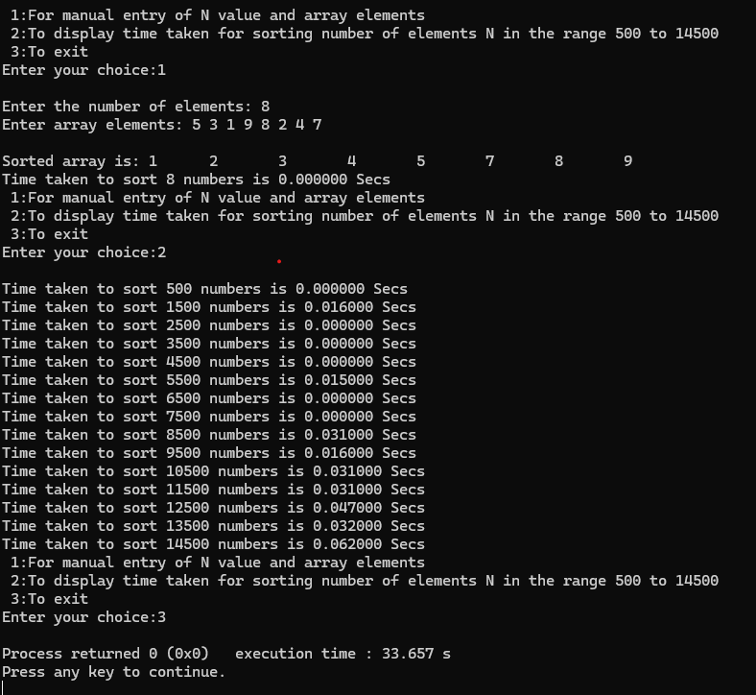

**7.Implement Johnson Trotter algorithm to generate permutations**.

#include <stdio.h>

#include <stdlib.h>

#include <time.h>

void merge(int arr[], int left, int mid, int right)

{

int n1 = mid - left + 1;

int n2 = right - mid;

int L[n1], R[n2];

for (int i = 0; i < n1; i++)

L[i] = arr[left + i];

for (int j = 0; j < n2; j++)

R[j] = arr[mid + 1 + j];

int i = 0;

int j = 0;

int k = left;

while (i < n1 && j < n2)

{

if (L[i] <= R[j])

{

arr[k] = L[i];

i++;

}

else

{

arr[k] = R[j];

j++;

}

k++;

}

while (i < n1)

{

arr[k] = L[i];

i++;

k++;

}

while (j < n2)

{

arr[k] = R[j];

j++;

k++;

}

}

void mergeSort(int arr[], int left, int right)

{

if (left < right)

{

int mid = left + (right - left) / 2;

mergeSort(arr, left, mid);

mergeSort(arr, mid + 1, right);

merge(arr, left, mid, right);

}

}

void printArray(int arr[], int size)

{

for (int i = 0; i < size; i++)

printf("%d ", arr[i]);

printf("\n");

}

int main()

{

int n;

clock_t start, end;

double cpu_time_used;

printf("Enter the number of elements: ");

scanf("%d", &n);

int arr[n];

printf("Enter %d integers:\n", n);

for (int i = 0; i < n; i++)

scanf("%d", &arr[i]);

printf("Unsorted array: ");

printArray(arr, n);

start = clock();

mergeSort(arr, 0, n - 1);

end = clock();

cpu_time_used = ((double)(end - start)) / CLOCKS_PER_SEC;

printf("Sorted array: ");

printArray(arr, n);

printf("Time taken to sort: %f seconds\n", cpu_time_used);

return 0;

}

OUTPUT:

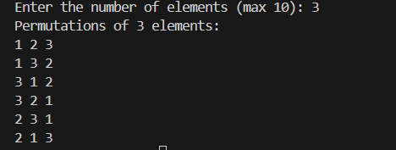

**B.Substring Matching Program.**

#include <stdio.h>

#include <string.h>

void substringMatch(char *str, char *sub) {

int strLen = strlen(str);

int subLen = strlen(sub);

int found = 0;

for (int i = 0; i <= strLen - subLen; i++) {

int j;

for (j = 0; j < subLen; j++) {

if (str[i + j] != sub[j]) {

break;

}

}

if (j == subLen) {

printf("Substring found at index %d\n", i);

found = 1;

}

}

if (!found) {

printf("Substring not found\n");

}

}

int main() {

char str[100], sub[100];

printf("Enter the main string: ");

gets(str); // Using gets() for simplicity, but it's better to use fgets() in practice.

printf("Enter the substring to search for: ");

gets(sub);

substringMatch(str, sub);

return 0;

}

OUTPUT:

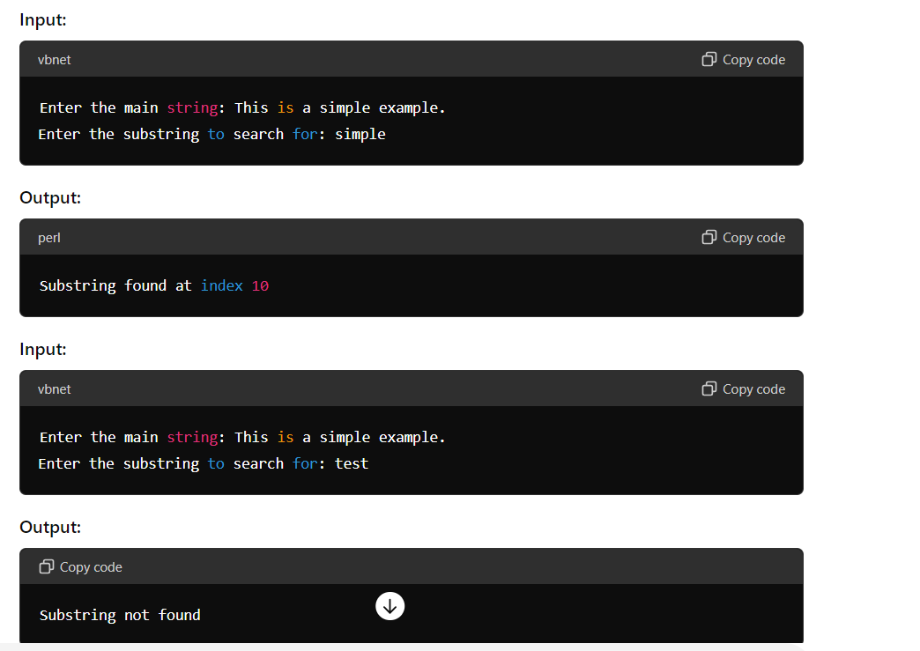

**C.Leetcode : exercise on Find Kth Largest Integer**

int cmp(const void*a,const void*b) {

const char* str1 = *(const char**)a;

const char* str2 = *(const char**)b;

if (strlen(str1) == strlen(str2)) {

return strcmp(str1, str2);

}

return strlen(str1) - strlen(str2);

}

char * kthLargestNumber(char ** nums, int numsSize, int k){

qsort(nums,numsSize,sizeof(char*),cmp);

return nums[numsSize-k];

}

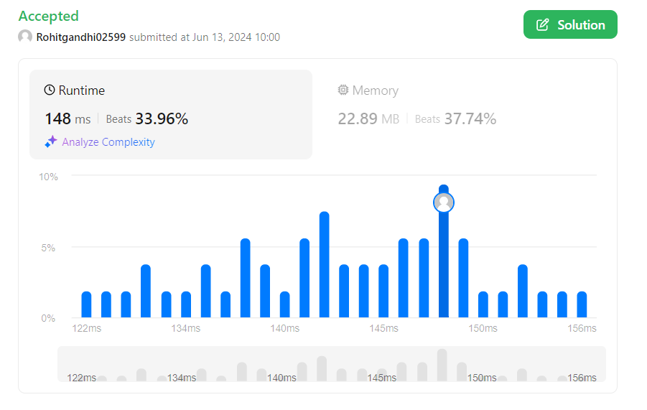

**8.Sort a given set of N integer elements using HEAP Sort technique and compute its time taken.**

#include <stdio.h>

#include <stdlib.h>

#include <time.h>

void swap(int *a, int *b)

{

int t = *a;

*a = *b;

*b = t;

}

int partition(int arr[], int low, int high)

{

int pivot = arr[high];

int i = (low - 1);

for (int j = low; j <= high - 1; j++)

{

if (arr[j] < pivot)

{

i++;

swap(&arr[i], &arr[j]);

}

}

swap(&arr[i + 1], &arr[high]);

return (i + 1);

}

void quickSort(int arr[], int low, int high)

{

if (low < high)

{

int pi = partition(arr, low, high);

quickSort(arr, low, pi - 1);

quickSort(arr, pi + 1, high);

}

}

void printArray(int arr[], int size)

{

for (int i = 0; i < size; i++)

printf("%d ", arr[i]);

printf("\n");

}

int main()

{

int n;

clock_t start, end;

double cpu_time_used;

printf("Enter the number of elements: ");

scanf("%d", &n);

int arr[n];

printf("Enter %d integers:\n", n);

for (int i = 0; i < n; i++)

scanf("%d", &arr[i]);

printf("Unsorted array: ");

printArray(arr, n);

start = clock();

quickSort(arr, 0, n - 1);

end = clock();

cpu_time_used = ((double)(end - start)) / CLOCKS_PER_SEC;

printf("Sorted array: ");

printArray(arr, n);

printf("Time taken to sort: %f seconds\n", cpu_time_used);

return 0;

}

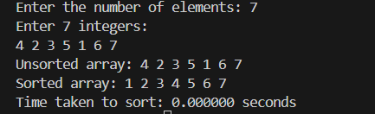

**B.Floyds Algorithm:**

#include <stdio.h>

#include <limits.h>

#define V 4

void printSolution(int dist[][V])

{

printf("Shortest distances between every pair of vertices:\n");

for (int i = 0; i < V; i++)

{

for (int j = 0; j < V; j++)

{

if (dist[i][j] == INT_MAX)

printf("INF\t");

else

printf("%d\t", dist[i][j]);

}

printf("\n");

}

}

void floydWarshall(int graph[][V])

{

int dist[V][V];

for (int i = 0; i < V; i++)

for (int j = 0; j < V; j++)

dist[i][j] = graph[i][j];

for (int k = 0; k < V; k++)

{

for (int i = 0; i < V; i++)

{

for (int j = 0; j < V; j++)

{

if (dist[i][k] != INT_MAX && dist[k][j] != INT_MAX && dist[i][k] + dist[k][j] < dist[i][j])

dist[i][j] = dist[i][k] + dist[k][j];

}

}

}

printSolution(dist);

}

int main()

{

int graph[V][V] = {

{0, 5, INT_MAX, 10},

{INT_MAX, 0, 3, INT_MAX},

{INT_MAX, INT_MAX, 0, 1},

{INT_MAX, INT_MAX, INT_MAX, 0}};

floydWarshall(graph);

return 0;

}

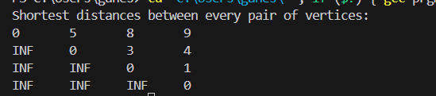

**9.(a ) Implement 0/1 Knapsack problem using dynamic programming.**

#include <stdio.h>

int max(int a, int b)

{

return (a > b) ? a : b;

}

int knapsack(int W, int wt[], int val[], int n)

{

int i, w;

int K[n + 1][W + 1];

for (i = 0; i <= n; i++)

{

for (w = 0; w <= W; w++)

{

if (i == 0 || w == 0)

K[i][w] = 0;

else if (wt[i - 1] <= w)

K[i][w] = max(val[i - 1] + K[i - 1][w - wt[i - 1]], K[i - 1][w]);

else

K[i][w] = K[i - 1][w];

}

}

return K[n][W];

}

int main()

{

int n, W;

printf("Enter number of items: ");

scanf("%d", &n);

int val[n], wt[n];

printf("Enter values and weights of items:\n");

for (int i = 0; i < n; i++)

{

printf("Enter value and weight for item %d: ", i + 1);

scanf("%d %d", &val[i], &wt[i]);

}

printf("Enter maximum weight capacity of knapsack: ");

scanf("%d", &W);

int max_value = knapsack(W, wt, val, n);

printf("Maximum value that can be obtained: %d\n", max_value);

return 0;

}

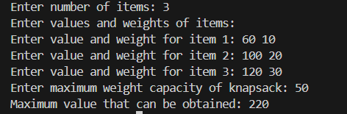

**(b) . Find Minimum Cost Spanning Tree of a given undirected graph usingPrim’s algorithm.**

#include <stdio.h>

#include <stdlib.h>

#include <limits.h>

#define V 5

int minKey(int key[], int mstSet[])

{

int min = INT_MAX, min_index;

for (int v = 0; v < V; v++)

if (mstSet[v] == 0 && key[v] < min)

min = key[v], min_index = v;

return min_index;

}

void printMST(int parent[], int graph[V][V])

{

printf("Edge \tWeight\n");

for (int i = 1; i < V; i++)

printf("%d - %d \t%d \n", parent[i], i, graph[i][parent[i]]);

}

void primMST(int graph[V][V])

{

int parent[V];

int key[V];

int mstSet[V];

for (int i = 0; i < V; i++)

key[i] = INT_MAX, mstSet[i] = 0;

key[0] = 0;

parent[0] = -1;

for (int count = 0; count < V - 1; count++)

{

int u = minKey(key, mstSet);

mstSet[u] = 1;

for (int v = 0; v < V; v++)

if (graph[u][v] && mstSet[v] == 0 && graph[u][v] < key[v])

parent[v] = u, key[v] = graph[u][v];

}

printMST(parent, graph);

}

int main()

{

int graph[V][V] = {

{0, 2, 0, 6, 0},

{2, 0, 3, 8, 5},

{0, 3, 0, 0, 7},

{6, 8, 0, 0, 9},

{0, 5, 7, 9, 0},

};

primMST(graph);

return 0;

}

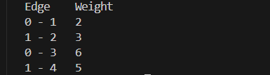

**10.From a given vertex in a weighted connected graph, find shortest paths to other vertices using Dijkstra’s algorithm.**

#include <stdio.h>

#include <limits.h>

#include <stdbool.h>

#define MAX 100

int minDistance(int dist[], bool sptSet[], int V)

{

int min = INT_MAX, min_index;

for (int v = 0; v < V; v++)

if (sptSet[v] == false && dist[v] <= min)

min = dist[v], min_index = v;

return min_index;

}

void printSolution(int dist[], int V)

{

printf("Vertex \t Distance from Source\n");

for (int i = 0; i < V; i++)

printf("%d \t\t %d\n", i, dist[i]);

}

void dijkstra(int graph[MAX][MAX], int src, int V)

{

int dist[V];

bool sptSet[V];

for (int i = 0; i < V; i++)

dist[i] = INT_MAX, sptSet[i] = false;

dist[src] = 0;

for (int count = 0; count < V - 1; count++)

{

int u = minDistance(dist, sptSet, V);

sptSet[u] = true;

for (int v = 0; v < V; v++)

if (!sptSet[v] && graph[u][v] && dist[u] != INT_MAX && dist[u] + graph[u][v] < dist[v])

dist[v] = dist[u] + graph[u][v];

}

printSolution(dist, V);

}

int main()

{

int V;

printf("Enter the number of vertices: ");

scanf("%d", &V);

int graph[MAX][MAX];

printf("Enter the adjacency matrix (enter 0 if there is no edge between two vertices):\n");

for (int i = 0; i < V; i++)

for (int j = 0; j < V; j++)

scanf("%d", &graph[i][j]);

int src;

printf("Enter the source vertex: ");

scanf("%d", &src);

dijkstra(graph, src, V);

return 0;

}

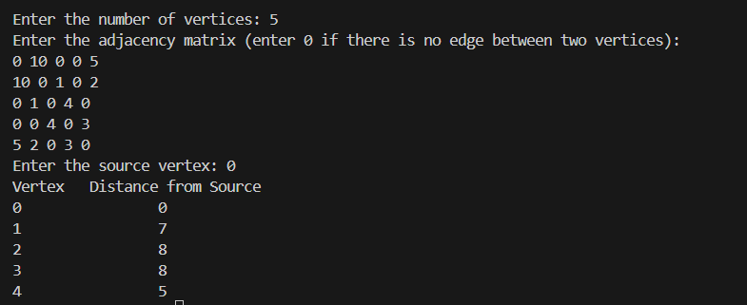

**( b ) Find Minimum Cost Spanning Tree of a given undirected graph using Kruskal’s algorithm**.

#include <stdio.h>

#include <stdlib.h>

#define MAX_VERTICES 20

struct Edge

{

int src, dest, weight;

};

void Union(int parent[], int rank[], int x, int y);

int find(int parent[], int i);

void KruskalMST(struct Edge *edges, int V, int E);

int find(int parent[], int i)

{

if (parent[i] != i)

parent[i] = find(parent, parent[i]);

return parent[i];

}

void Union(int parent[], int rank[], int x, int y)

{

int xroot = find(parent, x);

int yroot = find(parent, y);

if (rank[xroot] < rank[yroot])

parent[xroot] = yroot;

else if (rank[xroot] > rank[yroot])

parent[yroot] = xroot;

else

{

parent[yroot] = xroot;

rank[xroot]++;

}

}

int compareEdges(const void *a, const void *b)

{

struct Edge *edge1 = (struct Edge *)a;

struct Edge *edge2 = (struct Edge *)b;

return edge1->weight - edge2->weight;

}

void KruskalMST(struct Edge *edges, int V, int E)

{

struct Edge result[V];

int e = 0;

int i = 0;

qsort(edges, E, sizeof(struct Edge), compareEdges);

int parent[V];

int rank[V];

for (int v = 0; v < V; ++v)

{

parent[v] = v;

rank[v] = 0;

while (e < V - 1 && i < E)

{

struct Edge next_edge = edges[i++];

int u = find(parent, next_edge.src);

int v = find(parent, next_edge.dest);

if (u != v)

{

result[e++] = next_edge;

Union(parent, rank, u, v);

}

}

printf("Edges in the Minimum Spanning Tree:\n");

for (i = 0; i < e; ++i)

{

printf("%d -- %d == %d\n", result[i].src, result[i].dest, result[i].weight);

}

}

int main()

{

int V, E;

printf("Enter the number of vertices: ");

scanf("%d", &V);

printf("Enter the number of edges: ");

scanf("%d", &E);

struct Edge edges[E];

printf("Enter the source, destination, and weight of each edge:\n");

for (int i = 0; i < E; ++i)

{

scanf("%d %d %d", &edges[i].src, &edges[i].dest, &edges[i].weight);

}

KruskalMST(edges, V, E);

return 0;

}

